B.TECH. (2020-24)
Artificial Intelligence

Lab File
(Experiment 1 & 2)
on
Digital Electronics and Computer Organization
[CSE207]

Submitted To
Ms Neha Arora

Submitted By
Hitesh
A023119820027
4CSE11 (AI)

DEPARTMENT OF COMPUTER SCIENCE AND ENGINEERING
AMITY SCHOOL OF ENGINEERING AND TECHNOLOGY
AMITY UNIVERSITY UTTAR PRADESH
NOIDA (U.P)
INDEX

S. No. | Experiment Number | Date of Allotment of Experiment | Signature of Faculty
1 | Exp 1 To verify and interpret the logic and truth table for AND, OR, NOT, NAND, NOR, Ex-OR, Ex-NOR gates. | 07/01/2022
2 | Exp 2 To study and design the single bit half adder and full adder combinational circuits by using (1) XOR and (2) NAND gates respectively to verify and interpret their logic and truth tables and analyse the working of half adder and full adder circuit. | 14/01/2022
3
4
5
6
7
8
9
10

Experiment – 1
LOGIC GATES

Experiment – 1

AIM
To verify and interpret the logic and truth table for AND, OR, NOT, NAND, NOR, Ex-OR, Ex-NOR gates.

PLATFORM/TOOL USED
- Simulator: https://circuitverse.org/simulator
- Virtual LAB: https://de-iitr.vlabs.ac.in/exp/realization-of-logic-functions/

THEORY
Logic gates are electronic circuits which perform logical functions on one or more inputs to produce one output.
AIM: To verify and interpret the logic and truth table for
AND, OR, NOT, NAND, NOR, Ex-OR, Ex-NOR gates using RTL
(Resistor Transistor Logic), DTL (Diode Transistor Logic) and
TTL (Transistor Transistor Logic) logics.
THEORY: Logic gates are the basic building blocks of any
digital system. Logic gates are electronic circuits having one
or more than one input and only one output. The relationship
between the input and the output is based on a certain logic.
Based on this, logic gates are named as
1) AND gate
2) OR gate
3) NOT gate
4) NAND gate
5) NOR gate
6) Ex-OR gate
7) Ex-NOR gate
AIM: To verify and interpret the logic and truth table for
AND, OR, NOT, NAND, NOR, Ex-OR, Ex-NOR gates using RTL
(Resistor Transistor Logic), DTL (Diode Transistor Logic) and
TTL (Transistor Transistor Logic) logics.
THEORY: Logic gates are the basic building blocks of any
digital system. Logic gates are electronic circuits having one
or more than one input and only one output. The relationship
between the input and the output is based on a certain logic.
Based on this, logic gates are named as
1) AND gate
2) OR gate
3) NOT gate
4) NAND gate
5) NOR gate
6) Ex-OR gate
7) Ex-NOR gate
They are the basic building blocks of any digital system. Logic gates are electronic circuits having one or more than one input and only one output. The relationship between the input and the output is based on a certain logic. Based on this, there are seven logic gates –
- AND gate
- OR gate
- NOT gate
- NAND gate
- NOR gate
- Ex-OR gate
- Ex-NOR gate
When all the input combinations of a logic gate are written in a series and their corresponding outputs written along them, then this input/ output combination is called Truth Table.
The Karnaugh Map (K-Map) method is a systematic way of simplifying Boolean expressions. With the help of the K-map method, we can find the simplest POS and SOP expression, which is known as the minimum expression. The K-map provides a cookbook for simplification.
Just like the truth table, a K-map contains all the possible values of input variables and their corresponding output values. However, in K-map, the values are stored in cells of the array. In each cell, a binary value of each input variable is stored.

- AND Gate
- The AND gate is an electronic circuit that gives a high output (1) only if all its inputs are high. A dot (.) is used to show the AND operation i.e. A.B or can be written as AB.
- The IC number of AND Gate is 7408.

Truth Table of AND Gate
INPUT |  | OUTPUT
A | B | Y = A.B
0 | 0 | 0
0 | 1 | 0
1 | 0 | 0
1 | 1 | 1

K- Map of AND Gate
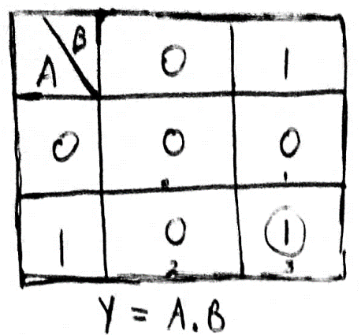

Boolean Expression of AND Gate
Y = A.B

Logic Symbol of AND Gate
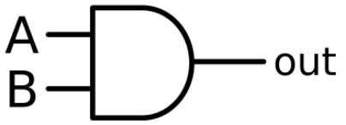
- OR Gate
- The OR gate is an electronic circuit that gives a high output (1) if one or more of its inputs are high. A plus (+) is used to show the OR operation.
- The IC number of OR Gate is 7432.
Truth Table of OR Gate
INPUT |  | OUTPUT
A | B | Y = A+B
0 | 0 | 0
0 | 1 | 1
1 | 0 | 1
1 | 1 | 1

K- Map of OR Gate
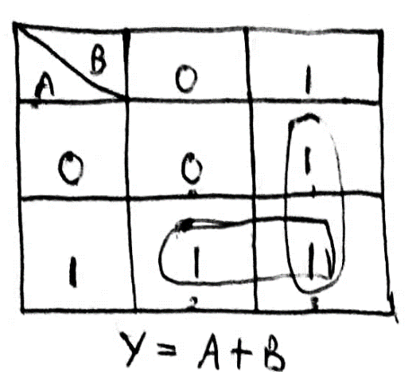

Boolean Expression of OR Gate
Y = A+B

Logic Symbol of OR Gate
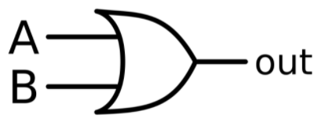
- NOT Gate
- The NOT gate is an electronic circuit that produces an inverted version of the input at its output. It is also known as an inverter. If the input variable is A, the inverted output is known as NOT A.
- The IC number of NOT Gate is 7404.
Truth Table of NOT Gate
INPUT | OUTPUT
A | Y = $\overline{A}$
0 | 1
1 | 0

Boolean Expression of NOT Gate
Y = $\overline{A}$

Logic Symbol of NOT Gate
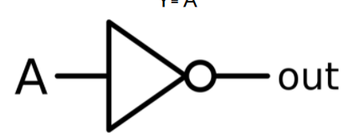
- NAND Gate
- This is a NOT-AND gate which is equal to an AND gate followed by a NOT gate. The outputs of all NAND gates are high if any of the inputs are low. The symbol is an AND gate with a small circle on the output. The small circle represents inversion.
- The IC number of NAND Gate is 7400.
Truth Table of NAND Gate
INPUT |  | OUTPUT
A | B | Y = $\overline{AB}$
0 | 0 | 1
0 | 1 | 1
1 | 0 | 1
1 | 1 | 0

K- Map of NAND Gate
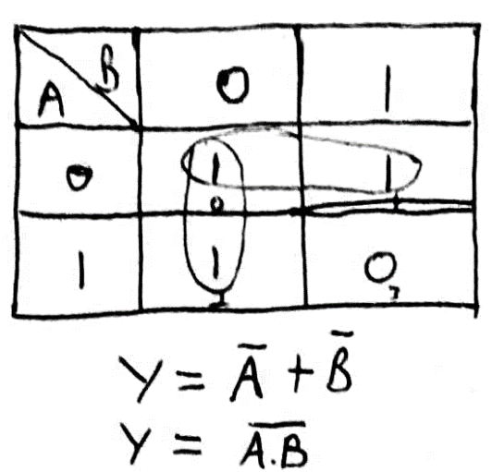

Boolean Expression of NAND Gate
Y = $\overline{AB}$

Logic Symbol of NAND Gate
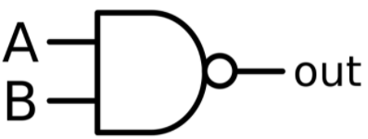
- NOR Gate
- This is a NOT-OR gate which is equal to an OR gate followed by a NOT gate. The outputs of all NOR gates are low if any of the inputs are high. The symbol is an OR gate with a small circle on the output. The small circle represents inversion.
- The IC number of NOR Gate is 7402.

Truth Table of NOR Gate
INPUT |  | OUTPUT
A | B | Y = $\overline{A+B}$
0 | 0 | 1
0 | 1 | 0
1 | 0 | 0
1 | 1 | 0

K- Map of NOR Gate
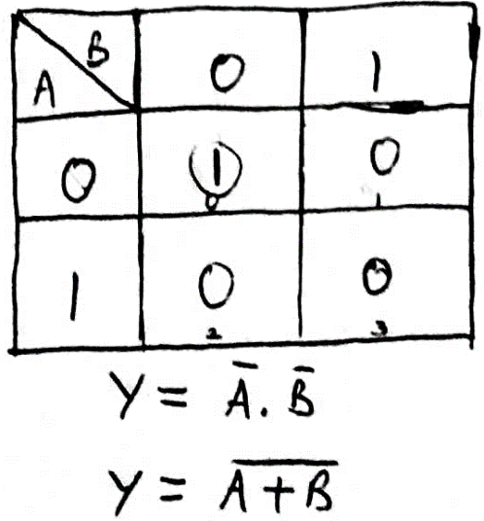

Boolean Expression of NOR Gate
Y = $\overline{A+B}$

Logic Symbol of NOR Gate
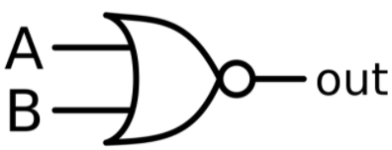
- Ex-OR Gate
- The 'Exclusive-OR' gate is a circuit which will give a high output if either, but not both of its two inputs are high. An encircled plus sign (⊕) is used to show the Ex-OR operation.
- The IC number of X-OR Gate is 7486.

Truth Table of XOR Gate
INPUT |  | OUTPUT
A | B | Y= A⊕B
0 | 0 | 0
0 | 1 | 1
1 | 0 | 1
1 | 1 | 0

K- Map of XOR Gate
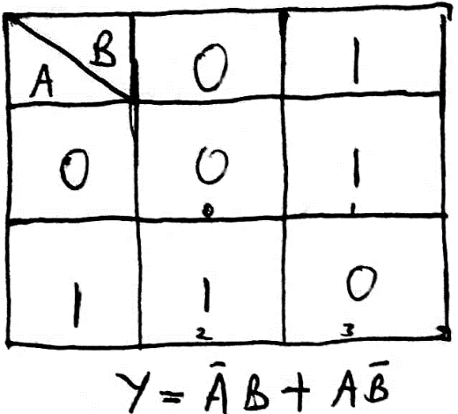

Boolean Expression of XOR Gate
Y= A⊕B

Y = $\overline{A}$B + A$\overline{B}$

Logic Symbol of XOR Gate
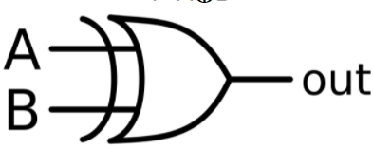
- Ex-NOR Gate
- The 'Exclusive-NOR' gate circuit does the opposite to the EX-OR gate. It will give a low output if either, but not both of its two inputs are high. The symbol is an EX-OR gate with a small circle on the output. The small circle represents inversion.
- The IC number of Ex-NOR Gate as CMOS IC is the 4077, and the TTL IC is the 74266.

Truth Table of XOR Gate
INPUT |  | OUTPUT
A | B | Y= $\overline{A⊕B}$
0 | 0 | 1
0 | 1 | 0
1 | 0 | 0
1 | 1 | 1

K- Map of XOR Gate
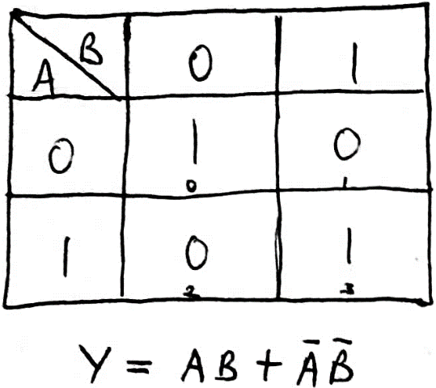

Boolean Expression of XOR Gate
Y= $\overline{A⊕B}$
Y = AB + $\overline{A}\overline{B}$

Logic Symbol of XOR Gate
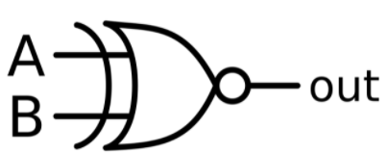

SIMULATED OUTPUT
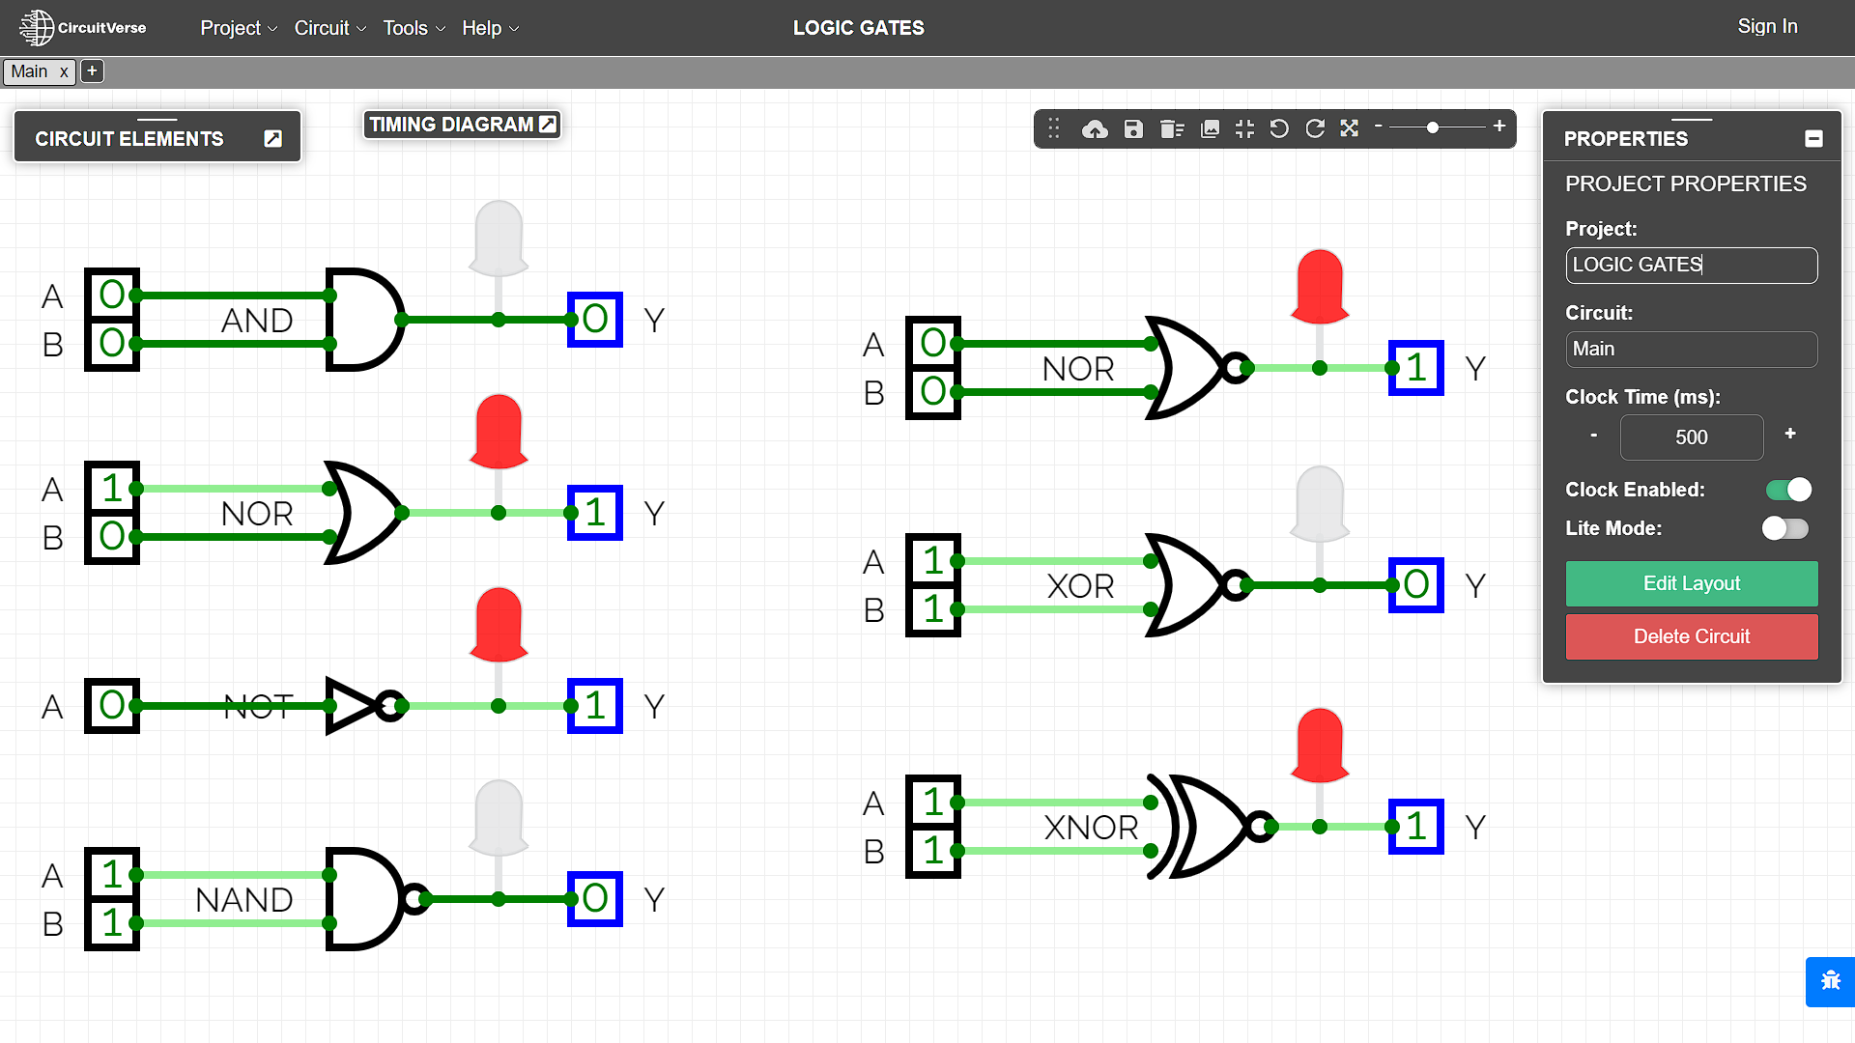

RESULT
The Boolean Expressions and Truth Tables of Logic and Universal gates have been studied and verified using the online simulator.

Criteria | Total Marks | Marks Obtained | Comments
Concept (A) | 2
Implementation (B) | 2
Performance (C) | 2
Total | 6

Experiment – 2
COMBINATIONAL CIRCUITs:
Half ADDER & Full ADDER

Experiment – 2

AIM
To study and design the single bit half adder and full adder combinational circuits by using (1) XOR and (2) NAND gates respectively to verify and interpret their logic and truth tables and analyse the working of half adder and full adder circuit.
PLATFORM/TOOL USED
- Simulator: https://circuitverse.org/simulator
- Virtual LAB: https://de-iitr.vlabs.ac.in/exp/half-full-adder/
THEORY
An Adder is a digital logic circuit in electronics that is extensively used for the addition of numbers. In many computers and other types of processors, adders are even used to calculate addresses and related activities and calculate table indices in the ALU and even utilized in other parts of the processors.
Adders are a key component of arithmetic logic unit. Adders can be constructed for most of the numerical representations like Binary Coded Decimal (BCD), Excess – 3, Gray code, Binary etc. out of these, binary addition is the most frequently performed task by most common adders. Apart from addition, adders are also used in certain digital applications like table index calculation, address decoding etc.

Binary addition is like that of decimal addition. Some basic binary additions are shown below.
0 0 1 1
+0 +1 +0 +1
0 1 1 (carry) 1 0

Adders are basically classified into two types: Half Adder and Full Adder.

- Half Adder
- Half adder is a combinational circuit that performs simple addition of two binary bits.
- It has 2 inputs that represent the 2 bits to be added and 2 outputs, with one producing the SUM output and the other producing the CARRY.
- If we assume A and B as the two bits whose addition is to be performed, the block diagram and a truth table for half adder with A, B as inputs and Sum, Carry as outputs can be tabulated as follows:

Block Diagram for HALF ADDER
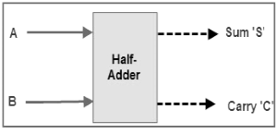

Truth Table for HALF ADDER
INPUT |  | OUTPUT
A | B | Carry (C) | Sum (S)
0 | 0 | 0 | 0
0 | 1 | 0 | 1
1 | 0 | 0 | 1
1 | 1 | 1 | 0

K-Map for HALF ADDER
For SUM For CARRY
B  A | 0 | 1 |  |  | B  A | 0 | 1
0 | 0 | 1 |  |  | 0 | 0 | 0
1 | 1 | 0 |  |  | 1 | 0 | 1
$$Sum = AB^{'}+ A^{'}B$$  $$Sum=A⊕B$$ |  |  |  |  | $$Carry = AB$$

Boolean Expression for HALF ADDER
$\boxed{Sum = AB^{'}+ A^{'}B=A⊕B}$ $\boxed{Carry = AB}$

Logic Diagram for HALF ADDER
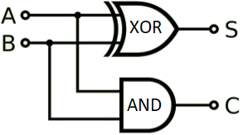

- Five NAND gates are required to design a half adder.

Realization of Half Adder using 5 NAND gates
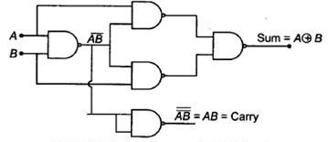
- Full Adder
- Full adder is a digital combinational circuit used to calculate the sum of three binary bits. Full adders are complex and difficult to implement when compared to half adders.
- It consists of 3 inputs and 2 outputs.
- The full adder overcomes the limitation of the half adder, which can be used to add two bits only.
- Two of the three bits are same as before which are A, the augend bit and B, the addend bit. The additional third bit is carry bit from the previous stage and is called 'Carry-in' generally represented by C_{IN}. It calculates the sum of three bits along with the carry. The output carry is called 'Carry-out' and is represented by C_{OUT}.
- As there 3 input variables, 8 different output combinations are possible.
- The block diagram and truth table of a full adder with A, B and C_{IN} as inputs and S, Carry OUT as outputs can be tabulated as follows:
Block Diagram for FULL ADDER
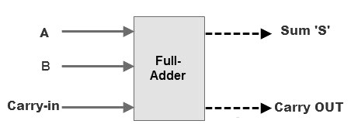
Truth Table for FULL ADDER
INPUT |  |  | OUTPUT
A | B | C_{IN} | SUM | C_{OUT}
0 | 0 | 0 | 0 | 0
0 | 0 | 1 | 1 | 0
0 | 1 | 0 | 1 | 0
0 | 1 | 1 | 0 | 1
1 | 0 | 0 | 1 | 0
1 | 0 | 1 | 0 | 1
1 | 1 | 0 | 0 | 1
1 | 1 | 1 | 1 | 1

K-Map for FULL ADDER
For SUM |  |  |  |  |  | For Carry_{out}
BC_{IN}  A | 00 | 01 | 11 | 10 |  | BC_{IN}  A | 00 | 01 | 11 | 10
0 | 0 | 1 | 0 | 1 |  | 0 | 0 | 0 | 1 | 0
1 | 1 | 0 | 1 | 0 |  | 1 | 0 | 1 | 1 | 1
$$Sum =A^{'}B^{'}C_{in}+A^{'}BC_{in}^{'}+{AB}^{'}C_{in}^{'}+ABC_{in}$$  $$Sum=A⊕B ⊕C_{IN}$$ |  |  |  |  |  | $$C_{out} = AB+AC_{in}+AC_{in}$$  $$C_{out}=AB+C_{in}(A⊕B)$$

Boolean Expression for HALF ADDER
$$\boxed{Sum =A^{'}B^{'}C_{in}+A^{'}BC_{in}^{'}+{AB}^{'}C_{in}^{'}+ABC_{in}=A⊕B ⊕C_{IN}}$$
$$\boxed{C_{out} = AB+AC_{in}+AC_{in}=AB+C_{in}(A⊕B)}$$

Logic Diagram for FULL ADDER
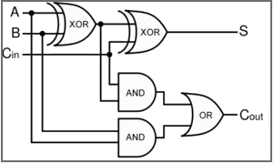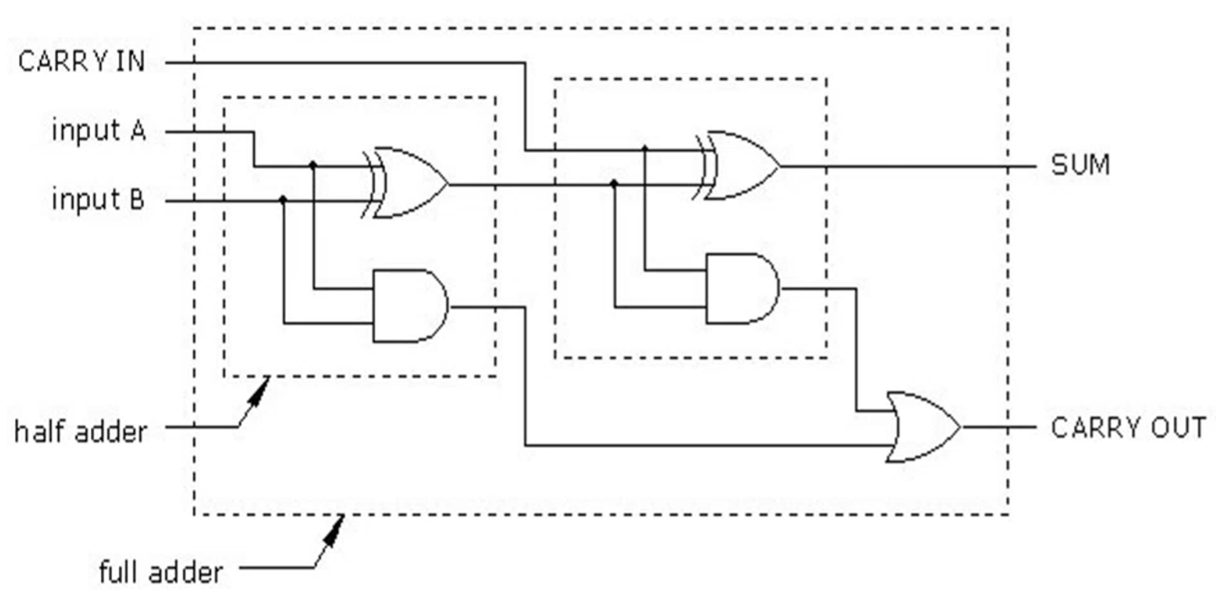

- Nine NAND gates are required to design a full adder.

Realization of FULL Adder using 9 NAND gates
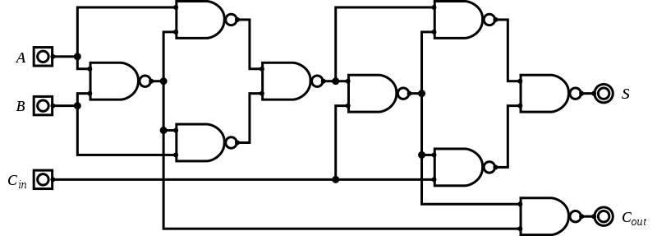
SIMULATED OUTPUT

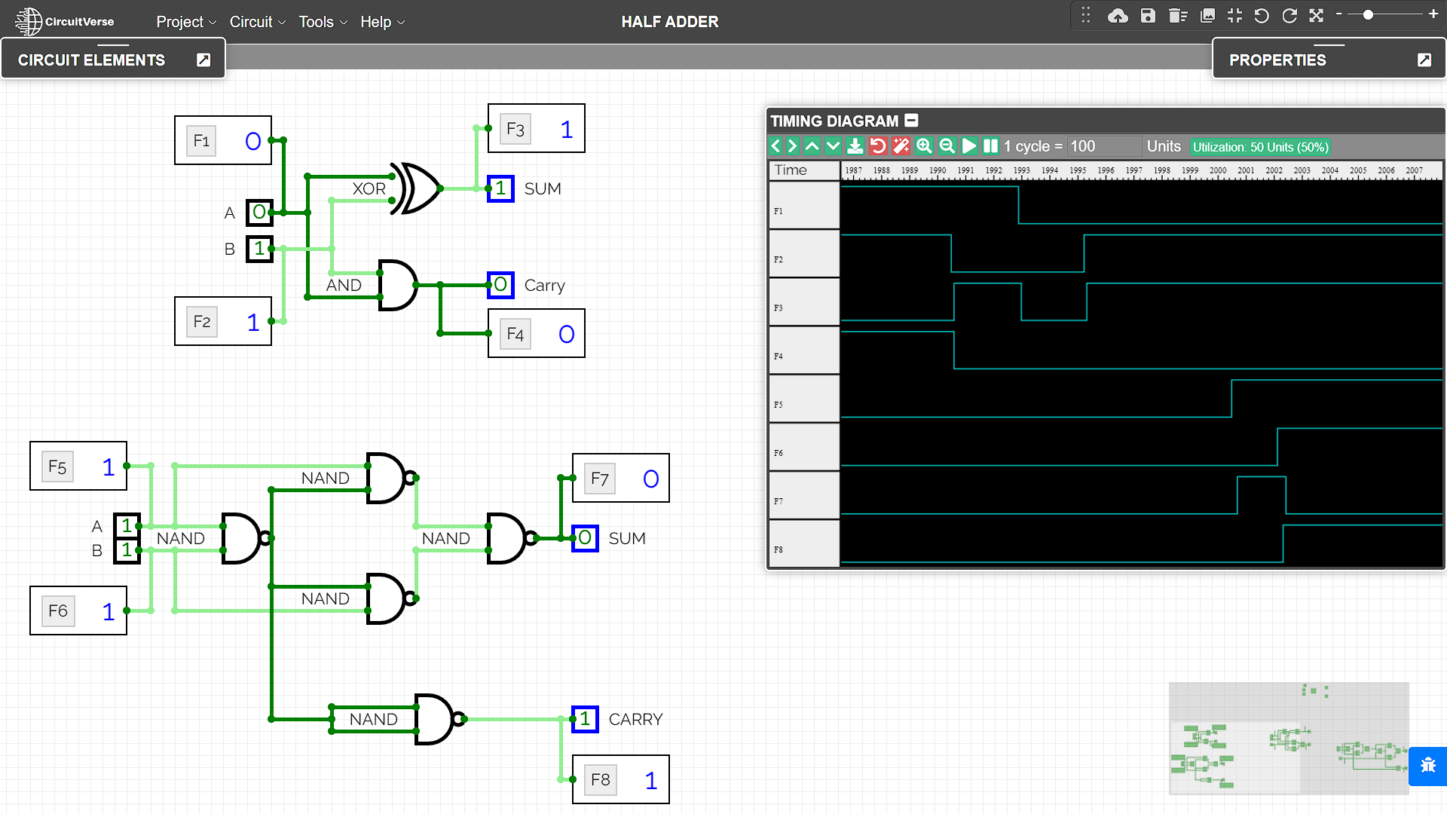

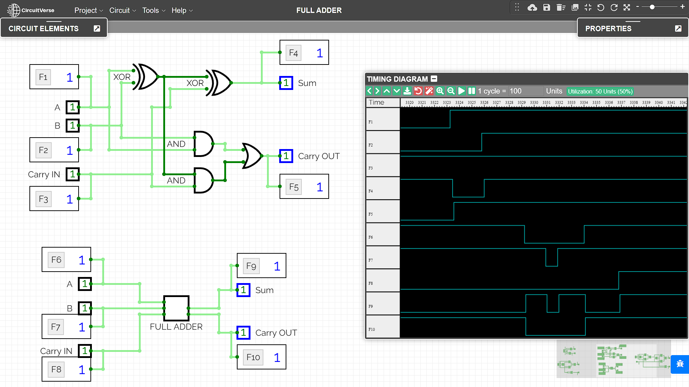

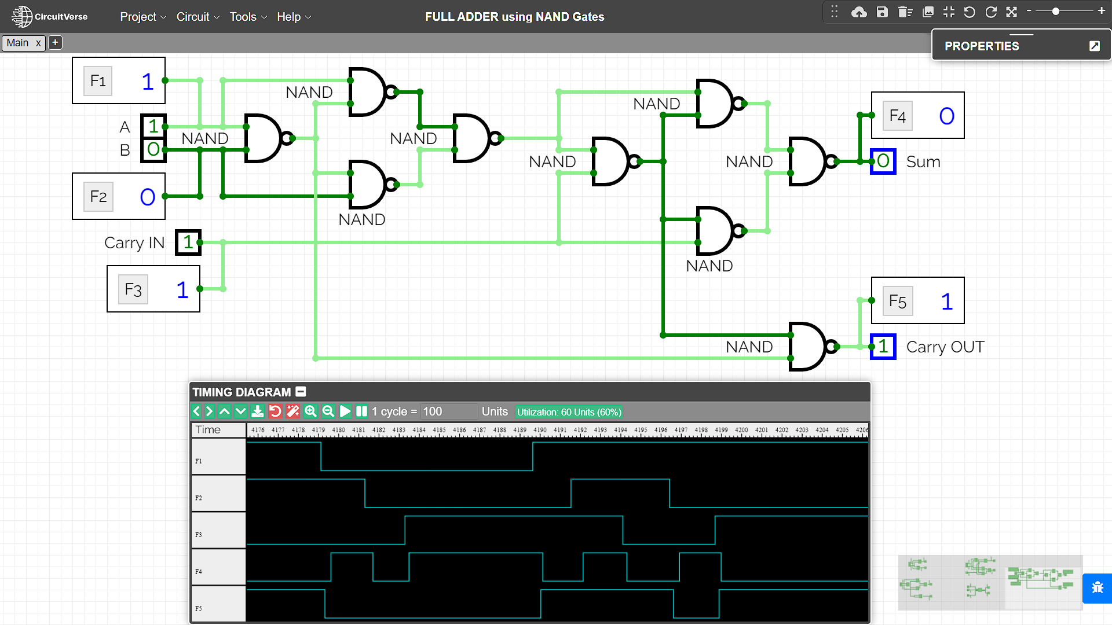

RESULT
The Working of Half adder and Full adder combinational circuit have been analysed and the Truth Tables and Boolean Expressions of half adder and full adder using XOR and NAND gates have been studied and verified using the online simulator.

Criteria | Total Marks | Marks Obtained | Comments
Concept (A) | 2
Implementation (B) | 2
Performance (C) | 2
Total | 6

